Key Words
Unipolar depression: a type of mood disorder causing periods of feeling sad and lacking motivation to do everyday activities.
Monozygotic twins: twins developed from one fertilised egg that has split into two; monozygotic twins are genetically identical.
Dizygotic twins: twins developed from two different eggs fertilised during the same pregnancy; dizygotic twins are not genetically identical.
Genetic predisposition: a biological tendency to develop a particular behaviour as a result of the genes someone has.
Diathesis-stress model: an explanation for depression that claims people can have a gene that makes them more likely to develop depression, but only if they face a stressful situation that triggers depressive thoughts.
Deterministic: our actions come from what we are born with and what we experience; this is the opposite of having ‘free will’ or free choice.
Free will: explanations of behaviour that claim we have the ability to choose exactly what type of behaviour we want to show; this is the opposite of being ‘determined’.
Cognitive theory: an explanation that focuses on how thought processes influence behaviour
Negative triad: a set of three thought patterns where people feel bad about themselves, the future and the world in general.
Nature: explanations of behaviour that focus on innate factors (the things we are born with).
Nurture: explanations of behaviour that focus on environmental factors (the things that happen to us).
Neurotransmitters: chemicals found within the nervous system that pass messages from one neuron to another across a synapse.
Reuptake: the process by which neurons reabsorb neurotransmitters that they released.
Placebo: an inactive substance, or ‘fake pill’, used instead of an active substance. The person given a placebo will not know it is fake.
Relapse: a return of symptoms after treatment has been given.
Addiction: a mental health problem that means people need a particular thing – a substance or an activity – in order to be able to go about their normal routine.
Withdrawal: a set of unpleasant physical or psychological symptoms someone gets when they are trying to quit or cannot satisfy their addiction
Functional analysis: the first stage of CBT to treat addiction that identifies triggers.
Skills training: the second stage of CBT to treat addiction whereby addicts learn ways to control the patterns of behaviour that lead to their addiction.
Detoxification: when an addict tries to stop taking the substance they are addicted to

Depression
Symptoms | Explanations | Treatment
Physical (Tired, weight loss, difficulty sleeping)  Behaviours (withdrawal from others, doesn’t get things done, stops doing enjoyable activities, difficulty concentrating)  Thoughts (“It’s my fault” “I’m a failure” “Life is not worth living”.  Feelings (Unhappy, overwhelmed, frustrated) | Genetic explanation: 17 different gene variations are linked to developing depression. McGuffin et al. (1996) found that if one MZ twin became depressed, there was a 46% chance that their twin would also become depressed. This decreased for DZ twins, at only 20%. However, maybe there needs to be an environmental stressor that triggers depressive thoughts (diathesis stress model).  Cognitive theory:  Becks cognitive triad Beck’s ABC Model  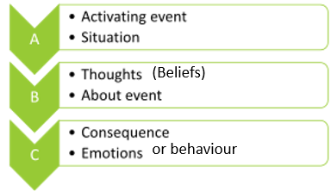  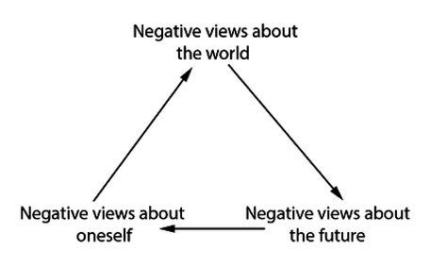 | CBT: Aims to change the way that people think in order to change their behaviour. Irrational ways of thinking are challenges and replaced with reational ones.  Drug therapy: Anti-depressant drugs work on increasing the levels of neurotransmitters such as serotinin. Types include: SSRIs, SNRIs, MAOIs and TCAs.
*Use SCOUT to evaluate these theories.

Psychological Problems
Addiction
Symptoms | Explanations | Treatment
Tolerance to substance, a feeling that you must take or do something, withdrawal symptoms, ignoring evidence that it is harmful, difficult to stop. | Genetic: DDR2 gene linked to depression (A1 variation of this gene)  Classical conditioning: learning behaviour through association with something positive.  Operant conditioning: Behaviour is encouraged/discouraged through reinforcement and punishment.  Social learning theory: Behaviour is learned through observation. | CBT: It aims to help people understand the triggers for their addictive behaviours and then learn how to control and manage these behaviours. CBT occurs in two key stages: functional analysis followed by skills training.  Drug therapy: Drugs can reduce withdrawal symptoms and can reduce cravings (e.g. nicotine replacement therapy)

Caspi et al (2003) Influence of Life Stress on Depression: Moderation by a Polymorphism in the 5-HTT Gene | Young (2007) Cognitive Behaviour Therapy with Internet Addicts: Treatment Outcomes and Implications.
Aim: To see why stressful experiences lead to some people developing depression and the role or serotonin.  Procedure: Participants were group depending on their variation of the 5-HTTLPR gene. Stressful life events were measured between their 21st and 26th birthday. Depressive symptoms were measured at age 26.  Results: Stressful life events predicted major depression among carriers of an (s) allele. Childhood maltreatment predicted adult depression only among those carrying the (s) allele.  Conclusion: The 5-HTT gene interacts with life events to predict depressive symptoms. Those carrying the (l) allele were less likely to develop depression. | Aim: To investigate the effectiveness of CBT for those suffering from internet addiction.  Procedure: 114 participants were involved in CBT over a number of weeks. They were give a questionnaire to complete after the 3rd, 8th and 12th online sessions and then at a 6 month follow up.  Results: Most participants saw an improvement by session 3 and this continued through session 8 and 12.  Conclusion: CBT led to a decrease in thoughts and behaviours associated with compulsive internet use.

*Use GRAVE to evaluate these studies

