Key Words
Brain- The organ in your head made up of nerves that processes information and controls behaviour.
Hemisphere- Half of the brain; if we imagine a person facing forward and then look down on the brain from the top, the right hemisphere is on the right side of the brain, while the left hemisphere is on the left.
Cerebrum- The largest part of the brain where higher processing happens; it includes the cortex.
Frontal Lobe- The area at the front of the brain responsible for decision-making and impulse control.
Temporal Lobe- The area one the side of the brain that controls hearing and memory.
Parietal Lobe- The area at the top of the brain that plays an important role in perception and sensations of touch.
Occipital Lobe- The area at the back of the brain that controls vision.
Cerebellum- An area of the brain to the brainstem that controls motor movements.
Lateralisation of function- The different jobs that are done by each half of the brain; each hemisphere will have different specialist roles that it performs.
Asymmetrical- The two hemispheres of the brain are not equal in terms of what they do; each hemisphere controls different functions, or plays a larger or smaller role in a particular behaviour.
Corpus Callosum- A thick bundle of nerve fibres connecting the two hemispheres of the brain so they can communicate with each other.
Broca’s Area- A part of the left hemisphere of the brain that controls speech production.
Spatial Awareness- The ability to negotiate space and navigate our way around our environment.
Neurotransmitters- Chemicals found within the nervous system that pass messages from one neuron to another across a synapse.
Neuron- A nerve cell that transmits information.
Synaptic Transmission- The process by which neurotransmitters are released by a neuron, move across the synaptic gap and are then taken up by another neuron.
Synapse- A gap between two neurons that allows messages, in the form of neurotransmitters, to pass from one cell to another.
Axon- The long structure that connects the cell body of a neuron to the terminal button at the end of the cell.
Terminal branch/button- The end of a neuron.
Vesicle- Small sacs/membranes containing neurotransmitter (chemical) molecules.
Receptors- Special sites on neurons that are designed to absorb neurotransmitter molecules.
Pre-frontal cortex- The area of the brain’s cortex at the very front of the frontal lobe, immediately behind the forehead.
Fusiform Facial Area- Part of the temporal lobe, close to the occipital lobe, that is thought to help in face recognition.
White Matter- Brain and spinal cord tissue, consisting mainly of nerve fibres (axons).
Neuroscience- The scientific study of the brain and nervous system.
EEG- A method of measuring brain activity using electrodes placed on the scalp.
MRI- A method of studying the brain using electromagnets.

Neuropsychology
Structure and Function of the Brain | Lateralisation | Sex Differences in the Brain
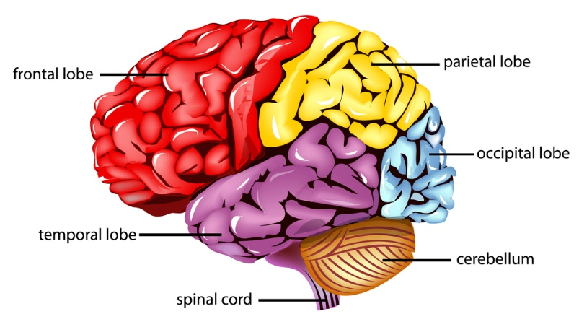 | Lateralisation of function in the brain means that each hemisphere of the brain has different jobs.  Some behaviours are controlled more from the left than the right and vice versa.  Left side- language  Right side- spatial awareness, facial recognition | Males and females brains work differently  Females were better at language skills (left-brain tasks)  Men were better at spatial skills (right-brain tasks) such as imagining what a shape would look like if it was shown from a different angle  Females may have a thicker corpus callosum meaning they may use both sides of their brain for some tasks  Males show dominance for one hemisphere for the same tasks with more activity in one hemisphere than the other
Issues and Debates – How psychology has changed over time | Neurological Damage
- (1670s) Microscopes have continued to develop in power to be able to analyse cells in the brain.  - (1848) Phineas Gage’s case encouraged doctors to investigate how the brain influences our behaviour. In these times we could only really study the brain after someone had died and we could remove the brain.  - (1875) Psychology was born in 1875 in Germany when Wundt (German researcher) opened the first laboratory for psychology.  - (1924) Berger developed the EEG brain scan which helped us to measure brain activity in people who are alive.  - (Late 1970s) More modern forms of brain scanning such as MRI and PET scans were developed that give us more detailed information about how the brain works. | Visual Agnosia  Visual Agnosia is a problem with the way the brain processes sensory information. The individual cannot recognise something that is presented to them (can’t understand what they are seeing). The part of the brain affected is the Parietal lobe. Symptoms might not be able to recognise colours, places and objects.  Prosopagnosia  Prosopagnosia is also known as ‘face blindness’. A person’s eyes can send information to the brain, however the brain is unable to recognise the face. The part of the brain affected is the Temporal lobe (in particular the Fusiform Face area- FFA). Symptoms might be not being able to recognise family members or friends
*Use SCOUT to evaluate these theories.

Sperry (1968)- Hemisphere Deconnection and Unity in Conscious Awareness. | Damasio et al. (1994) The Return of Phineas Gage: Clues About the Brain from the Skull of a Famous Patient.
Aim: To find out the cognitive functions that are linked to each hemisphere in the brain.  Procedure: Using 11 split brain patients, Sperry used a piece of apparatus that allowed testing of the right and left halves of the visual field separately or together to conduct 6 tasks involving saying what words or pictures the participant had seen or pointing to or picking up objects and identifying them.  Results: The left visual field was being processed by the right hemisphere and the left hand by the right hemisphere, and vice versa. Patients could name an object if they held it in their right hand.  Conclusion: The right hemisphere is superior when it comes to spatial awareness and the left is superior in processing language. | Aim: To identify the location of damage in Phineas Gage using modern neuroimaging techniques.  Procedure: Mapped out a 3D image of Phineas Gage’s skull using X rays and precise measurements to create a coordinate system to determine the likely trajectory and entry points of the iron rod.  Results: One of the five acceptable trajectories appeared to be the best fit. This suggested that all of the damage occurred in the frontal lobes; Broca’s area was undamaged (Broca’s area is linked to language ability); the motor cortices were undamaged; ventromedial region of both frontal lobes were damaged.  Conclusion: Ventromedial frontal region was involved in emotion and the underlying ‘neural machinery’ that participates in decision making.
*Use GRAVE to evaluate these studies

