 | 1171: Murder of Thomas Becket |  | 1327: Isabella forces Edward II to abdicate | 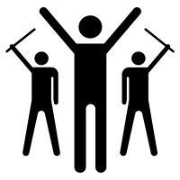 | 1485: the end of the Plantagenet Dynasty
1153: Henry II becomes the first Plantagenet King | 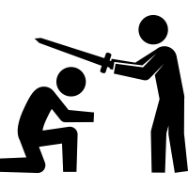 | 1215: Magna Carta | 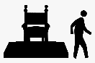 | 1381: Peasants’ Revolt

Key people, ideas and developments
1 | The Plantagenet Dynasty | The Plantagenet Dynasty ruled England between 1153 and 1485, in the High and Late Medieval Period. The first Plantagenet King was Henry II, and the throne passed to his sons when he died, then to other members of the family.
2 | Absolute monarchy | During the Medieval Period, the monarch was expected to have absolute power and rule through the feudal system. However, many monarchs faced challenges to their power.
3 | The power of the Church | The Catholic Church was very powerful during the Medieval Period, partly because the whole population followed the same religion. The most powerful church position in England was the Archbishop of Canterbury.
4 | Henry II | Henry II was known as a good king who brought stability and good leadership after a time of civil war.
5 | Thomas Becket | Thomas Becket was one of Henry II’s close friends, so Henry appointed him as Archbishop of Canterbury in the hope that it would allow him to have more power over the church. However, Becket took his religious role seriously and the two men argued over the church’s legal powers. Becket was sent into exile for six years. Henry had an angry outburst when Becket returned, criticising his government for letting him be treated in such a way by Becket, and three knights took his words as an instruction, went to Canterbury and killed Becket at his cathedral.
6 | King John | ‘Bad King John’ was an ineffective ruler. He raised high taxes to pay for wars that he lost. He was cruel: he imprisoned and murdered his nephew and there were rumours he starved his opponents to death.
7 | The Barons | The barons were angry with John for his poor leadership, loss of wars and high taxes. They put together an army and threatened a war. John was forced to make an agreement with them called Magna Carta, which placed limits on his power. Although Magna Carta was broken many times, it has great symbolic significance as an important moment in limiting the power of absolute rulers.
8 | Edward II and Isabella | Edward II married Isabella, the daughter of the King of France. Edward was a weak and unpopular ruler and the two had a difficult relationship. Like John, he lost wars and made poor leadership decisions. Edward confiscated Isabella’s property and took her children away from her.
9 | The “She-Wolf” of France | When Isabella was visiting France, she worked with a baron, Roger Mortimer, to invaded England, forcing Edward to abdicate. Her young son, Edward III, was crowned king, but as he was too young to rule, she and Mortimer held power for several years.
10 | Growing peasant anger | After an epidemic, The Black Death, killed a third to a half of the population, there were huge changes in society and peasants started to demand higher wages. However, a new law stated their wages had to stay at the low level from before the Black Death. At the same time, radical ideas about equality were being shared, for example by the preacher John Ball. Peasant anger was growing, and it got much worse when they had to pay a tax called the poll tax.
11 | Revolting peasants | In 1381, angry peasants grabbed farm equipment to use as weapons and marched to London in rebellion. They attacked rich and powerful people and their property, including the king’s unpopular advisor. At a meeting between the king, Richard II, and the peasants, Richard promised to make changes and persuaded the peasants to stop rebelling. However, he went back on this promise.

Key terminology
Word | Definition | In a sentence
abdicate | As a monarch, to step down from or give up the throne. | Edward II abdicated in 1327.  Isabella and Mortimer forced Edward to abdicate.  After Edward’s abdication, his son became king.
absolute | Complete; an absolute monarch is one which holds complete power. | In the medieval period, England was an absolute monarchy.
archbishop | The most senior position in the church in a particular country; the archbishop has power over the bishops, who have power over the priests – priests run church services in local churches. | Thomas Becket was made Archbishop of Canterbury by Henry II.
dynasty | A ruling family, where the crown (monarchy) passes to another family member when the previous one dies. | The Plantagenet Dynasty ruled England between 1153 and 1485 | 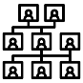
exile | To leave your country, either because you are sent away or because you need to leave to get away from danger. | Henry II sent Thomas Becket into exile.  Becket was exiled by Henry II. | 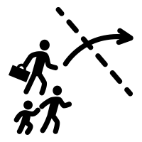
heir | The person who inherits, or gains, the throne after the previous monarch has died. | Richard I was the heir of Henry II. | 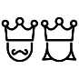
revolt | To fight against people who are in power using violence. | The Peasants’ Revolt was in 1381.  The peasants revolted because they were angry about the poll tax.
tax | Money that people have to pay to the government. | To pay for wars, King John imposed a new tax on the barons.  The poll tax made the peasants angry, leading to the Peasants’ Revolt.
treason | The crime of betraying your country or plotting against the monarch. | Roger Mortimer was executed for treason by Edward III. | 