History Bridging Work
For all note-making activities, you should put effort into how you are making notes. Remember that:
- You learn very little if you copy out whole swathes of text. Be selective.
- You should use a system that allows you to find the information you need very quickly, e.g. Cornell system, clear headings or spider diagrams/mind maps
- Images help you to remember things. It doesn’t matter if the artistic merit is limited.

Tsarist and Communist Russia
Complete one-page profiles for:  - Tsar Alexander II  - Tsar Alexander III  - Tsar Nicholas II  - Vladimir Lenin  - Josef Stalin  - Nikita Khrushchev | You should research and include this information:  - Years of life and rule. Childhood and family.  - Circumstances of accession to the throne/rise to power; circumstances of the end of their reign/time in power  - Key achievements. Key failures and/or limitations.  - Political attitudes and priorities.  - Key advisors and allies – who were they? What was their role?

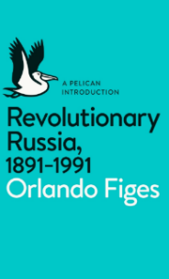
Additional reading you may want to consider:
Revolutionary Russia, 1891-1991 by Orlando Figes
This is an accessible academic book, giving a good summary of events. Available on Amazon - £6.99 paperback, £5.49 Kindle, or second hand offers from £3.50
BBC In Our Time (podcast) on the Emancipation of the Serfs (this event is significant in our first unit): https://www.bbc.co.uk/programmes/b0b2gspd

The Making of Modern Britain
Read the article below. Tasks follow underneath.

The UK’s five greatest prime ministers
24 JUN 2019, from political news magazine The Week
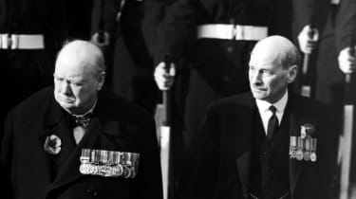
Legendary former British leaders Winston Churchill (L) and Clement Attlee
The UK is facing an uncertain future as Boris Johnson and Jeremy Hunt battle to claim the Tory leadership - and with it, the keys to No. 10.
As the nation prepares for the onset of a new political era, many commentators are looking back over that of Theresa May. The Guardian’s Owen Jones argues that May is “the worst prime minister – on their own terms – since Lord North’s reign in the late 18th century, when the US colonies declared their independence”.
Many other critics agree, citing her disastrous decision to hold a snap election in 2017 and mishandling of Brexit negotiations. Indeed, an unnamed Tory backbencher told Sky News that “every passing day she remains as prime minister, she is seizing from John Major the mantle of the worst prime minister in living memory”.
Amid all this talk of legacies, The Week takes a timely look back at five former British leaders whose reigns are widely - if sometimes controversially - viewed as having changed the country for the better:

1. Clement Attlee (Labour, 1945-1951)
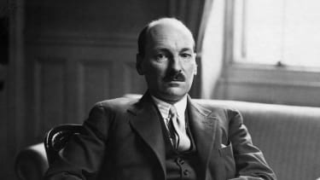
When it comes to lasting legacies, few British politicians can match the pedigree of Clement Attlee and his radical welfare reforms, which remain vital pillars of British society.
Attlee, who died in 1967, was voted the most successful British PM of the last century in a 2004 survey conducted by Ipsos MORI and the University of Leeds. “Respondents were asked to give their views on the greatest domestic and foreign policy successes and failures of the 20th century, and the majority of those responses singled out the Attlee government’s welfare state reforms and the creation of the NHS as the key 20th century domestic policy achievements,” the survey report says.
Attlee also claimed the top spot in two subsequent surveys by the university, in 2010 and 2016.
Dick Leonard of the Fabian Society, Britain’s oldest socialist think-tank, credits the Attlee government with transforming Britain for good. “It created the welfare state, including the NHS, rebuilt the ruined economy, nationalised a series of industries, whose record was a great deal better than it has been credited with, gave freedom to India, and played a vital role in the creation of NATO,” Leonard says.

2. Tony Blair (Labour, 1997-2007)
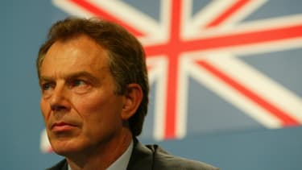
During most of his term, it seemed unfathomable that Tony Blair would leave office as one of the most controversial UK politicians of the 21st century.
After taking power in the largest landslide in British electoral history, he set about revitalising the sluggish post-Thatcher economy, and introduced the minimum wage, before enacting a series of foreign policy decisions that initially enhanced but eventually tarnished his reputation, in Northern Ireland, Kosovo and Iraq.
Given that record, it is a “great myth” that Blair didn’t achieve anything in office, insists GQ. “It’s not just Northern Ireland and the minimum wage: he left a vast legacy. Civil partnerships. Bank of England independence. The Welsh Assembly. The Scottish Parliament. A mayor of London. A plunging crime rate. Even abroad, his brand of liberal interventionism in Sierra Leone and Kosovo was a success. He is a hero to Kosovan Albanians, many of whom have named their children Tonibler in his honour,” the magazine says.

But as the BBC points out, his extremely divisive decision to intervene militarily in Iraq has “come to dominate the Blair legacy to such an extent that many of his notable achievements... are doomed to shelter under its shadow”.

3. Margaret Thatcher (Conservative, 1979-1990)
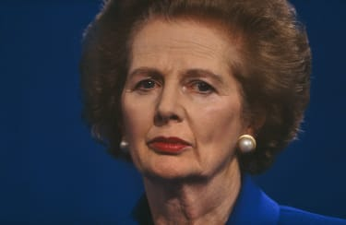
Perhaps the most polarising PM in British history, Margaret Thatcher’s legacy is that of free-market policies including trade liberalisation, deregulation, sweeping privatisation, breaking the power of the unions, individualism and the creation of an “enterprise culture” - an ideology that has come to be known as “Thatcherism”.
The former leader, who died in 2013, sought to impose a “creed of thrift, of self-reliance, of aspiration, of liberty in the purest sense”, and of “unswerving, ironclad patriotism – seen most obviously in her decision to launch a task force to reclaim the Falkland Islands, when so many siren voices suggested she let the junta’s aggression stand”, says The Daily Telegraph.
However, her boot-strap policies and harsh attitude toward striking miners has made her one of the most hated politicians in UK history among certain communities.
“She destroyed too many good things in society, and created too many bad ones, then left a social and moral vacuum in which the selfishly rich and unimaginatively fortunate could too easily destroy still more of what they don’t need and can’t see that everyone else does need,” author Emma Darwin has argued.
Nonetheless, Thatcher remains a towering figure, and an icon for Conservatives and free-trade enthusiasts the world over.

4. Winston Churchill (Conservative, 1940-1945 and 1951-1955)
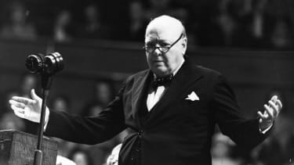
Repeatedly voted the greatest Briton of all time, Churchill is almost certainly the most iconic British PM, according to the BBC.
“The case for him is a powerful one, of course,” the broadcaster adds. “He was first a government minister in 1908, and occupied most of the top jobs in politics during half a century. He finally retired in 1955, having served as prime minister for a total of nine years. “But it was his extraordinary leadership in WWII that marked him out.”
However, Churchill’s reputation has been tarnished by increasing scrutiny in recent years of his relationship with British India. The legendary Tory, who died in 1965, considered independence leader Mahatma Ghandi a threat to the British Empire. Churchill has also been criticised for his tough attitudes on unions and workers rights, including a notorious incident in which soldiers were deployed in response to strikes in Tonypandy in South Wales during his tenue as home secretary.

5. David Lloyd George (Liberal, 1916-1922)
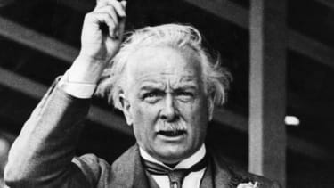
David Lloyd George, the MP for Caernarfon Boroughs, had already served as chancellor, minister of munitions and secretary of state for war during the First World War by the time he became PM in 1916. He was the first and only Welshman to hold the office and is the only British leader to have spoken Welsh as his first language.
As chancellor of the Exchequer, Lloyd George, who died in 1945, oversaw the introduction of many reforms which “laid the foundations of the modern welfare state”, says the North Wales Daily Post. But his biggest achievement came during his tenure as PM, when he played a major role at the Paris Peace Conference of 1919 that reordered Europe after the defeat of the Central Powers.
Indeed, Lloyd George was “acclaimed as the man who had won the War”, as well as leaving a positive social legacy for post-war Britain, says the UK government’s history portal.
Summer work tasks: (1-3 on paper, 4 using the grid overleaf, or alternatively on paper)
- The five figures above often appear in lists of “great Prime Ministers”. They are also all controversial figures for different reasons. Why do you think PMs who are considered “great” by some are often strongly criticised by others?
- Choose the one of the five above who in your view was Britain’s greatest PM. Read some more about their time in power and write a paragraph explaining why you consider them to be ‘great’. (If you would rather focus on a different PM who is not on this list, that’s also fine! Anyone from Walpole to present!)
- Come up with a list of three to five criteria by which you would judge “greatness” in a Prime Minister. You can use ideas from the article if you wish. They should be criteria that could lead to a judgement of “greatness” even in a PM whose political ideas you disagree with, i.e. criteria about how they approach the role rather than whether they are left or right wing, etc.
- Look up the following key terms and concepts that appear in the article and write definitions. Don’t just write the first thing you come across on Google – read about the term until you understand it and then write a definition based on your understanding.

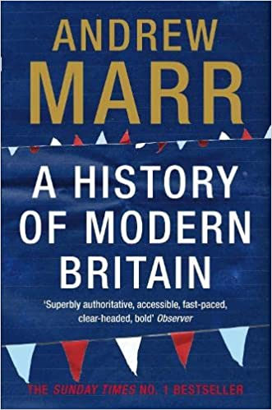
Additional reading you may wish to consider
Andrew Marr, A History of Modern Britain
A very accessible history of the period of this course, written for a general audience.

backbencher
welfare reforms
welfare state
domestic policy
foreign policy
democratic socialism
landslide victory
Bank of England
free market
deregulation of the economy
privatisation
trade union
strike
Chancellor of the Exchequer

