

Promoting Positive Relationships and Supporting Behaviour Regulation Policy

Date Policy updated: March 2021
Date Policy due to be reviewed: July 2021

Committee Responsible for Policy: Full Governing Body Committee
Section 1 – Policy Statement

This policy describes The Hillcrest School’s approach to promoting positive behaviour.

In order to achieve our aims to maintain a happy, responsible and fair school respected by the community and to raise achievements for all, we need good behaviour and good discipline. High standards of behaviour and discipline are essential for securing an orderly learning environment and improving classroom learning and raising achievement

Our policy is based on 2 key principles:
- Praise - leading to the issue of awards / rewards
- Choice – instilling in the students a clear sense that they choose how to conduct themselves and that from these choices will come positive or negative consequences

Positive behaviour is an essential component of an effective teaching and learning environment. Hillcrest School is committed to the promotion of positive behaviour for all students and to supporting students to develop their social, emotional and behavioural skills.

Hillcrest School has a holistic approach to education, valuing learning in and out of the classroom. We are an ‘Attachment Aware’ school which means we focus on building positive relationships between students and staff and students with their peers. We recognise that understanding our emotions is a key aspect of understanding and managing behaviour. Through ‘Emotion Coaching’ and being attachment aware, both students and adults are both able to manage their behaviour and create an environment that is conducive to learning. Ultimately, we wish to give our students’ confidence about their capacity to self-manage/self-regulate their emotions and behaviour.

Hillcrest School is committed to the emotional mental health and well-being of our students, parent/carers and staff. We wish to work towards this in all aspects of school life, and to provide an ethos, environment and curriculum that supports the social, emotional and mental health of the whole school community. We treat all students with unconditional respect and have high expectations for both adults’ and children’s learning and social behaviours. We understand that negative behaviour can signal a need for support which we will provide for individual students without diluting our expectations.

This policy is for all staff, students, parents/carers, governors, visitors and partner agencies working within the school and provides guidelines and procedures as to how our school supports and responds to behaviour. The promotion of self-discipline and respect for others also guides the school’s actions to promote positive behaviour and informs the school's response to any kind of bullying or intimidation.

The ‘Getting It Right’ policy fundamentally underpins and drives the ethos of the school. Students are informed about the expectations the school has of their behaviour, the manner in which these expectations will be rewarded and the response pupils can expect if they choose not to meet these expectations. It is based on respect for self, for others and for the environment. It is designed to encourage pupils to develop responsibility for their own behaviour and achievements. However, we do acknowledge that we have a responsibility to consider a student’s social, emotional and mental health needs when implementing the system and taking appropriate actions to deal with poor behaviour, as required.

The key principles of this policy are:
- to create a caring, orderly community in which effective learning can take place and where there is mutual respect between members;
- to ensure all stakeholders treat other people and their property with respect and consideration;
- to encourage students to become self-disciplined, able to accept responsibility for their own actions and make positive choices;
- to support students to behave in a manner which allows other students to enjoy their educational experiences at the Hillcrest school;
- to develop in all students the ability to listen to others; co-operate and to appreciate other ways of thinking and behaving
- to develop the Hillcrest community so that all members feel happy and safe, and develop a sense of worth, identity and achievement.

We aim to achieve this through a school behaviour policy based on rights, responsibilities and respect. We recognise that praise, rewards, privileges, and positive role-modelling support the development of self-discipline and the capacity to make positive choices.

We are aware that all children and young people may find the impact of the coronavirus (covid-19) pandemic particularly difficult and their increased stress will have a significant impact on their emotional well-being, engagement in learning and behaviour when they return to school. They may feel anxious as a result of staying at home for long periods of time, missing their friends, loss of their freedom and social interaction, loss of structure and daily routine, illness and bereavement in the family or friendship groups, caring for adults and/or siblings in the family home and concerns about the impact on their academic progress. As a school, we recognise the difficulty some students will face in re-engaging with structured learning, expectations, routines, relationships, social interactions, classroom dynamics and the school community. We will implement a holistic ‘emotional recovery approach’ which will focus on rebuilding the confidence and skills of all students to support them to reengage with their learning and continue as responsible members of our school community.

Policy Objectives

- To encourage positive behaviour, with all students and adults working to agreed standards
- To set expectations that all students will be encouraged to learn the social emotional and behavioural skills required for citizenship
- To maintain a school environment where students are encouraged to behave appropriately because they feel they are valued members of the school community, and that they are safe, secure and at ease.

Broad Guidelines for Behaviour and Discipline

1 | Every teacher will accept responsibility for high standards of discipline in the classroom and within the school environment.
2 | Every student will accept responsibility for high standards of behaviour.
3 | All staff will be consistent in their approach to discipline and behaviour and work within the framework of the Getting it Right policy.
4 | Every student will be made aware by their teachers and their tutors of the Code of Behaviour and the school’s high standards. The consequences of ignoring the ‘Getting It Right’ system will be clearly explained to students.
5 | The Headteacher alone has the right to exclude students and to decide whether the exclusion is to be held on or off the school premises.
Links to other policies
This policy links to the following other policies we hold in school:
- Anti-bullying policy
- Equality policy
- Safeguarding and Child Protection policy
- Care and Control policy
- On-line safety policy
- Health and Safety Policy
- Attendance policy
- Positive Mental Health policy
- Preventing Extremism policy
- Special Educational Needs policy

Section 2 - Teaching and Learning

Our approach to learning supports recognition and inclusion for all. Maintaining good behaviour is the responsibility of all staff, governors and parents. Promoting positive behaviour enables high standards of teaching and learning to be achieved. A well-designed and relevant curriculum helps develop and maintain positive behaviour. Students learn more effectively when the curriculum is differentiated, and teaching styles and approaches accommodate individual learning styles and preferences. Engaging teaching plays a significant role in a students’ attitude towards learning.

- Staff should use the most appropriate method of teaching, which draws on students’ social, emotional and learning experiences and values their contributions.
- Students should be received into a classroom where routines are established and high standards expected.
- Explicit and regular praise should be used for all types of achievement.

The school follows a ‘Positive Behaviour Management’ system (see examples below) which encourages all staff members to create learning environment to motivate students to behave appropriately in lessons. This approach is vitally important as part of our ‘emotional recovery approach’ as students return to school after the coronavirus (Covid-19) pandemic period. We will endeavour to provide students with the skills and space to rebuild their confidence as learners and self-regulators. Effective classroom management skills are developed through experience and appropriate support from colleagues. Training and reflection on personal practice is very important, particularly in the implementation of whole school ‘emotion coaching’ strategies as part of the wider ‘positive behaviour management’ system.

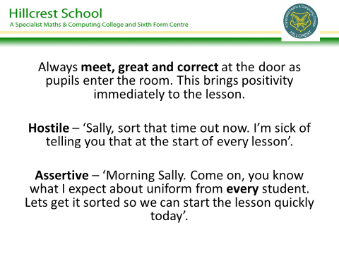
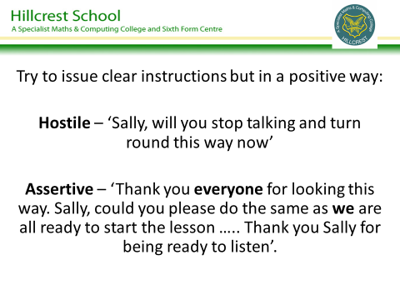
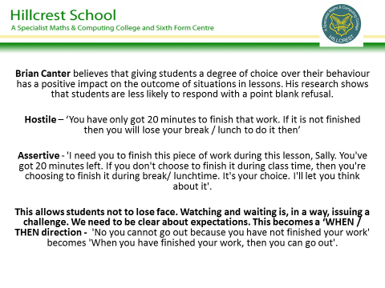
In addition, well-prepared and stimulating lessons, in which pupils are aware of the lesson purpose, help to secure good standards of behaviour. Effective lessons are those in which pupils enjoy learning, are fully engaged, make progress and improve their attainment through sustained effort and commitment.
Effective lessons:
- give the big picture
- use positive language
- have high expectations
- address different learning styles
- review learning
- move pupils’ learning on
- acknowledge and praise effort and progress
- provide students with the opportunity to talk about their feelings towards the learning and the support they may need to become more resilient and effective learners (particularly students who are anxious about falling behind with their work during the Covid-19 period)
- have challenge, pace and enjoyment.

To achieve this staff should:
- set behavioural objectives, when appropriate, as well as other learning objectives for the lesson
- arrive before the class and start the lesson on time
- ensure that students enter and leave the room quietly and sensibly
- display lesson objectives clearly
- refer regularly to the Code of Conduct
- ensure that all students are able to participate fully in the lesson
- emphasise the positive in learning and behaviour
- use praise and rewards fairly and consistently
- motivate, encourage and engage the pupils
- model and teach positive behaviour, including respect, empathy and social skills
- build positive and mutually trusting relationships with students
- make sparing, effective and fair use of reprimands
- avoid sarcasm, shouting and threats
- avoid humiliating pupils
- use both verbal and non-verbal communication techniques
- avoid punishing a class for the behaviour of individuals
- keep to time in the lesson and finish on time
- share good practice with colleagues
- allow students to talk openly about their feelings towards the learning process
- implement ‘Emotion Coaching’ strategies and interventions appropriate to the social and emotional needs of the student

ENCOURAGING POSITIVE BEHAVIOUR

We will ALL consistently apply the ‘Getting it Right’ Policy and ensure that we apply or carry out the following: Please refer to ‘A Guide to Getting it Right.’ (see appendix 1)

CHALLENGE
- Emphasise ‘listening skills’, ‘politeness’ and ‘respect’
- The ‘jewellery policy’ in all
- The ‘uniform policy’ in lessons
- Speaking when member of staff is talking
- Inappropriate language and name calling

PUNCTUALITY
- Every member of staff challenges every student who is out of a lesson. The student should have the permission section of their student planner signed.
- All staff to (a) issue a C1 if students are more than five minutes late to lessons without an acceptable reason.

CORRIDOR BEHAVIOUR
- Ensure you are on duty as per the ‘Duty Rota’.
- Keep to the left on corridors and stairs.
- No shouting/running

START AND END OF LESSONS
- Meet and greet the class - be at the door before they arrive.
- Queue in straight lines outside classroom (where possible).
- Enter in single file, stand behind desks, and wait to be greeted before sitting down.
- Register taken whilst students write down learning outcomes/starter activity.
- End of lesson, stand behind chairs, check for litter, marks on desks. Ensure the next class has a positive learning environment to come into. ‘DTNCAF’ - Do the next class a favour!
- Dismissed by rows in silence.

REWARDS
- There should be a 5:1 praise to sanction ratio
- All staff to issue at least 20 GIR Bonus Points each half term.
- All staff to issue at least ten Praise Cards each term. (If you do not have a full timetable please reduce accordingly.)
- All staff to issue Community Award Certificate if students participate in activities.

ASSEMBLIES
- All staff to arrive at the Theatre Hall or Studio ready for assembly to commence at 9.00
- Staff attached to a Year group to attend relevant Assemblies.
- SLT and College Learning Leaders as per Assembly rota

Section 3 - Maintaining Discipline

Staff are encouraged to apply their own behaviour management techniques as they develop their relationship with teaching groups. It is important to establish clear routines and expectations and implement a range of strategies that will solve any potential behavioural issues in the longer term.

During lessons it is vitally important for staff to implement their own behaviour management strategies alongside any consequences they may issue. All staff should consider the social and emotional needs of individual students when implementing strategies. This is particularly important as students return to school after missing a significant amount of direct teaching during the Covid-19 pandemic. The trauma, stress and anxiety, developed as a result of the lockdown period, may manifest itself in poor behaviour and limited engagement in learning. The ‘Getting It Right’ policy is there to support all staff but is not the only behaviour strategy open to staff. For example, staff might;

- Speak to a student before they enter the room and set clear expectations
- Use non-verbal forms of communication to reinforce behaviour expectations
- Move or suggest moving a student to another seat
- Use praise to remind a student of their ability to behave appropriately
- Pair the student with another student who will have a positive impact on their behaviour and attitude towards learning
- Vary the activity to find ways of encouraging the specific student to engage positively in the learning experience
- Allow the student to take some time out of the lesson before re-engaging them back into the lesson

Staff may consider using the following techniques throughout the academic year.

- Modified intervention / seating plan at start of the lesson
- Moved student to another seat during the lesson
- Consider behavioural / learning needs of individual students during the lesson planning process to ensure students can either access or feel engaged with the learning
- Set targets with the student for future improvement
- Modified approach to student, i.e. – effective use of praise / rewards
- Discussed issue with other department staff to identify other possible strategies
- Discussed issue with other staff who teach the identified student to explore successful strategies
- Discussed issues with College Learning Leader / Form Tutor
- Notified parents of behavioural issue (letter, message in planner)

Section 4 - Practice and Procedures: Roles and Responsibilities

The promotion of positive behaviour is the responsibility of all members of the school community, including parents and carers. Not all members of the school will play the same part in this process, but each section of the community will have a specific role.

The governing body will continue to work with other members of the school community to review and, if necessary, revise the principles underpinning this policy. For example, they will ensure that the policy and its implementation is consistent with the school’s equal opportunities policy. Specific responsibilities of the governing body include:

- approving policies, including this behaviour policy
- monitoring fixed term and permanent exclusions
- ensuring the needs of students at risk of permanent exclusion are met.

The Headteacher, with the assistance of other members of the Leadership Team, is responsible for the form and content of the policy, and for its implementation in ways that maintain a school ethos that encourages positive behaviour.

All staff have a responsibility to ensure the policy informs their day-to-day actions and that they apply the policy fairly and consistently. All staff have a role to play in keeping the policy alive throughout the school, including through providing mutual support to colleagues, and modelling the social, emotional and behaviour skills and high standards of behaviour expected from students.

Students have a role in shaping and promoting the school's behaviour policy. They will contribute to the detail of the policy through their involvement in defining expectations and rules, and developing rewards, motivational strategies, sanctions and consequences. This will be achieved through the School Council, form time and PSD days. Students have a responsibility to report incidents of bullying or intimidation, and a role in offering support to their peers through activities (peer ambassador mentoring)

Parents and carers have a responsibility for their child's behaviour inside and outside school, which they discharge by the standards they set and the way they encourage students’ progress at home. They also have a role to play in advising on the continuing development and improvement of the policy.

Section 5 - The ‘Getting It Right’ system

The ‘Getting It Right’ system underpins all aspects of the behaviour policy at the Hillcrest School. Staff and students are aware of the key elements of the system and its implementation in lessons and around school. The system is designed to both reward students for consistent high levels of work, attitude, behaviour and punctuality, as well as ensuring a tiered system of consequences for students who fail to ‘Get it Right’. (Appendix 1)

Sanctions
Sanctions should be used to help students make appropriate choices about their behaviour. Where they breach the ‘Getting It Right’ system, students have a right to expect fair sanctions, applied consistently. The most appropriate sanction is one designed to put matters right and to encourage better behaviour in the future. It is not appropriate, therefore, to punish whole groups for the misdemeanours of a few, or to impose a sanction that may humiliate students. Sanctions will lose their effectiveness if students do not regard them as fair. Staff are therefore advised to make it clear that they are condemning the behaviour not the person and avoid early escalation to severe sanctions, reserving them for the most serious or persistent breaches of the ‘Getting It Right’ system.

The ‘Getting It Right’ system has a definite set of tiered sanctions (see appendix 5) aimed to support students to reflect on and modify their behaviour in the classroom environment. Where students make inappropriate choices about their behaviour a series of consequences should be consistently followed by members of staff. Guidance is very clear for all staff on the reasons why students may receive a C3 for their behaviour in lessons, around school or in the wider community. However, staff are encouraged to use contextual information on a student’s social, emotional and mental health needs when implementing behaviour strategies. (see Appendix 1 and 2)

Students receiving a C3 in lessons or around the school will be sent to the Centre. The purpose of the period in the Centre is to support the student to reflect on their behaviour and consider different ways in which they could have managed their own behaviour. Students will remain in the Centre for a fixed period of time and receive a 60-minute Senior Leadership detention. Staff supervising the Centre will consider the student’s social, emotional and mental health needs, as well as the reason why the C3 was issued, when determining the length of time the student will remain in the Centre.

Getting It Right data is analysed by the Deputy Headteacher (Pastoral) on a weekly basis and appropriate data is shared with College Learning Leaders and Learning Managers each week. A half-termly analysis is also completed by the Deputy Headteacher of individual ‘Getting It Right’ totals and intervention plans, outlining appropriate strategies and support, are developed by the Learning Co-ordinators, form tutors, SENDCO and Designated Lead for Mental Health. College Learning Leaders and Learning Managers should consistently follow the procedures outlined in the whole school behaviour management system and intervention programme. (see appendix 3 and 5)

Students who fail to meet expectations on a weekly basis will be placed on a stage 1, 2 or 3 monitoring report for a fixed period of time. However, the Deputy Headteacher (Pastoral) will take a number of factors into account, including a student’s mental health and emotional well-being, when determining the level of pastoral monitoring and may explore other options to address the behavioural needs, ie – accessing support from Learning Mentor or Emotional Well-Being Co-ordinator. This approach will be particularly important in the case of any student struggling to adapt to routines and expectations after returning from the Covid-19 closure period. (see appendix 5)

Stage 1 Form Tutor Report
Students will be placed on a stage 1 report for two weeks for the following reasons:

- Receiving three consequences in a week
- Arriving late to school twice in a week

Stage 2 College Leader Report
Students will be placed on a stage 2 report for two weeks for the following reasons:

- Receiving 2 or more consequences in a week while on a stage 1 form tutor report
- Receiving 4 consequences in a week
- Arriving late to school three times in a week
- Receiving a C3 consequence in lessons
- Receiving a C2-C3 for behaviour out of lessons
- Receiving a second cumulative C3 consequence during the year

Stage 3 Senior Leadership Report
Students will be placed on a stage 3 report for three weeks for the following reasons:

- Receiving 2 or more consequences in a week while on a stage 2 CLL report
- Receiving a C3 while on stage 2 report
- Receiving 5 consequences in a week
- Late to school four times in a week
- Receiving 2 x C3 consequence in a week for behaviour in/out of lessons
- Receiving a third (or above) cumulative C3 consequence during the year
- Receiving an internal or external exclusion
- Failing to attend 2 SLT detentions

If a student fails to comply with the expectations outlined at each stage, there are clear interventions and consequences that will be followed by College Leaders and the Senior Leadership Team, as outlined in appendix 5.

Section 6 - Mobile phones / Smart Watches

Students are not allowed to have a mobile phone / smart watch visible in school from the moment they enter the school gates at the start of the day to the moment they leave the school gates at the end of the school day. This principle also applies to students who use their mobile phone during the school day even if they are not witnessed doing so by a member of staff, ie – student phones their parent to report an issue in school or to advise they are feeling unwell.

If a student is seen with a mobile phone/ smart watch, they will receive a C3 SLT detention but will not be sent to room 35 if they give their mobile phone to the member of staff. Parents/carers will be contacted by the relevant College Leader and the mobile phone / smart watch will remain locked in the school safe until the parent/carer collects from school. If this behaviour is repeated again, the mobile phone / smart watch will be confiscated and parents/carers will be invited into school to meet with their child’s College Leader. The device will be stored in the school safe until this meeting has taken place. If this behaviour is repeated for a third time, the mobile phone / smart watch will be confiscated and parents/carers will be invited into school to meet with the Deputy Headteacher (Pastoral). The device will be stored in the school safe until this meeting has taken place. If this be behaviour is repeated for a fourth time, the mobile phone /smart watch will be confiscated and parents/carers will be invited into school to meet with the Headteacher. The device will be stored in the school safe until this meeting has taken place.

If a student refuses to give their mobile phone / smart watch to the member of staff, they will be issued with a C3 (SLT detention) and sent to room 35. The student will then be required to give their mobile phone / smart watch to the member of staff in room 35. If the student hands over their mobile phone / smart watch, they will be issued with a one day internal isolation and the device will be kept in school until the parent/carer attends a meeting with the Deputy Headteacher (Pastoral). If this behaviour is repeated on a second occasion, the student will be issued with a one day internal exclusion and the device will be kept in school until the parent/carer attends another meeting with the Deputy Headteacher (Pastoral). If this behaviour is repeated on a third occasion, the student will be issued with a one day fixed term external exclusion and the device will be kept in school until the parent/carer attends a meeting with the Headteacher.

However, the school will view each case individually, as we are aware that students returning to school after the Covid-19 period may experience attachment difficulties as a result of being separated from family members and may feel they need their mobile phone to maintain contact with family members to check on their well-being. Students will still be required to hand their mobile phone to a member of staff but will not necessarily face the sanctions outlined above. Under these circumstances, the school will endeavour to make contact with home to alleviate the student’s anxiety and the device may be returned to the student at the end of the day, after securing agreement from the parent/carer.

Using a mobile phone or a similar device to record conversations, make videos or take photographs of any member of the school community (staff, students, visitors, parents/carers), without their permission, is not allowed and will result in a fixed term exclusion. Similarly, the display, supply or posting of any such materials will result in a fixed term exclusion.

However, we do not take responsibility for inappropriate use of digital media outside of school hours or outside of the school premises. Such issues which affect the running of the school will result in the involvement of any appropriate agency and the school following the ‘Getting it Right policy towards the individual’. However, the school reserves the right to issue a fixed term exclusion if a student’s physical or on-line behaviour, out of school, brings the school into disrepute. Under other circumstances, it will be the responsibility of the parent/carer to take further action in such matters.

The school does not take any responsibility for the loss or damage to any devices brought into the school by the student.

Section 7 - Rewards

Frequent praise and reward for achievement are features of teaching and learning at Hillcrest School, so that pupils receive recognition for their positive contributions to school life. The school believes that every student should have their achievements acknowledged and when appropriate rewarded. Such recognition:

- Builds student self-esteem and confidence.
- Helps to create a positive learning environment.
- Highlights the importance of good behaviour.
- Encourages students to participate in a variety of activities.
- Encourages students to set themselves the highest targets.
- Contributes to restoring and reinforcing positive student-staff relationships as the school reopens after the Covid-19 closure and rebuilds student’s confidence as learners

Getting It Right Rewards

Every term parents/carers will receive a letter informing them of the number of GIR points their child earned in comparison with the year group and school average. A list for each year group will be displayed each month to allow students to see their position in the year group in comparison with other students.

The Getting It Right system rewards students for excellent attendance, behaviour, punctuality, organisation and preparedness for learning. Students need to maintain attendance above 95% throughout the year as they can only earn GIR points on the days they are in school. At the end of the year students with a minimum of 95% GIR points will receive a ‘Hillcrest Star’ badge, a minimum of a bronze GIR certificate and earn a place at the GIR Winner’s Event. However, students will not be allowed to participate in the event if they receive more than 2 x C3, receive more than one exclusion from school, have attendance below 90% and are late for school more than 15 times, even if they achieve higher than 95%.

This threshold figure may be modified in 2020-21 to take individual circumstances into account due to the difficulty some students may have in returning to school after the covid-19 period. The Deputy Headteacher (Pastoral) will endeavour to take any mitigating circumstances into account when calculating all GIR scores.

At the end of each half-term students will be awarded with certificates to recognise their progress towards the expected minimum point’s threshold;

GOLD certificate – awarded to students who achieve >99-100% GIR
SILVER certificate – awarded to students who achieve >97-99% GIR
BRONZE certificate – awarded to students who achieve 95-97% GIR

At the end of the year a special celebration event will be held to celebrate the achievements of those students who achieve a GOLD GIR certificate.

GIR Bonus Points
We firmly believe in recognising good work and effort. We have a GIR Bonus Points Award Scheme through which students gain recognition of their achievements in relation to their academic work.

- 30 are required for a Bronze Certificate, 40 for a Silver Certificate, 50 for a Gold Certificate, 60 for a Platinum Certificate, 80 for a Diamond Certificate and 100 for an Emerald Certificate.

Praise Postcards
These will be posted home to students to inform their parents /carers of an achievement in school in relation to their academic work, attitude, good manners or anything else that deserves praise.

Community Certificates
These will be awarded to students who make a contribution to the Hillcrest community. This might include being part of a team, taking part in an event or being a guide when we have visitors in school.

Headteacher’s Tie
This will be awarded for exceptional performance or outstanding service in addition to ‘Hillcrest Superstars’ as indicated below:

‘Hillcrest Superstar’
This is the highest level of reward we have at Hillcrest. A Hillcrest Superstar will be someone who at the end of the year has:

- A minimum of 95% ‘Getting it Right’ Points
- 50 or more GIR Bonus Points
- 6 Community Certificates

OR An exceptional one-off achievement e.g. English Schools Athletics Gold Medal

Again, this threshold may be modified in 2020-21, based on the impact a potential phased return to school and individual absence, may have on a student’s ability to meet these specific thresholds.

Hillcrest Superstars will receive a special certificate and their names will be displayed on a Roll of Honour. They will also be awarded with a special Headteacher tie – one which is different in design to the school tie. Students who achieve the award for a second time receive a special glass trophy; for the third time a Headteacher Medal and for a fourth time a Headteacher Cup.

An Awards Morning is held annually to which parents/carers are invited. Prizes are presented to those who are judged to have made the most effort or progress or who have given outstanding service to the school throughout the year.

Section 8 – Detentions

All after school detentions are centralised and run by the staff as a whole on a rota basis and not individually. This takes away the need for staff to issue and hold their own detentions.

The purpose of detention is to contribute to the raising of students’ standard of behaviour across the school. We recognise and accept that a detention may not solve the underlying problem causing misbehaviour. However, it may cause students to ‘think twice’, and may act as a deterrent to others. The importance of a detention is that it gives a clear message to all students that as a school we will not accept poor attitudes to learning.

There are three forms of after school detentions: (see Appendix 4)

- Homework Support and Improvement Detentions (Tuesday or Thursday each week)
- Behaviour Detention (Tuesday and Thursday each week)
- SLT Detention (Friday each week)

Homework Support and Improvement Detentions

It is essential that students meet expected homework deadlines set by their teachers. Students who fail to complete a piece of homework and hand it in to their teacher by the expected deadline will receive a 30 minute ‘Homework Detention’. However, teachers may issue a ‘Homework Warning’ to a student if they fail to hand in their completed homework by the expected deadline due to exceptional circumstances (i.e. - illness of the student or immediate family member or a one-off IT failure). In such cases, the student would be issued an extended deadline to complete their homework. If, however, the homework is not completed by this extended deadline the student will be issued with a ‘Homework Detention’ and will still be expected to complete the piece of homework. Additionally, students can receive a 30 minute ‘Homework Improvement Detention’ if they complete a piece of homework but not to the expected standard in line with their ability or the teachers’ expectations. Students will be expected to use this detention to improve their homework to the expected standard. (see appendix 1 and 4)

During the detention students will be expected to complete the pieces of homework they missed or make improvements as necessary. The duty rota will allocate staff from a mixture of subjects, where possible, to ensure that students can access support from teachers from a range of curriculum subjects. Staff issuing the C2 must provide details on the nature / content of the missed homework by sending an email and relevant attachments to homework@hillcrest.bham.sch.uk Staff must clearly identify the name of the student and subject on the title of the email. Students will be allowed to use the computers to help them complete the homework if necessary.

If a student fails to attend the 30 minute detention they will be issued with 60 minute detention.

Behaviour Detentions

Students who receive a C2 for behaviour in lessons / around school will receive a 30 minute detention. If a student fails to attend the 30 minute detention they will be issued with a 60 minute detention.

Late Detentions

Students will receive the following levels of consequence based on the number of lates each week:

- Two lates in a week = 30 minute detention
- Three lates in a week = 60 minute detention
- More than 3 lates in a week = 60 minute detention and an internal isolation consequence

The school will take specific circumstances into account when deciding whether to issue a detention, ie – proof of a medical appointment, interview, personal family circumstances.

SLT Detentions

SLT detentions will take place on a Friday after school for 60 minutes. A student may receive an SLT detention for the following circumstances:

- Receives a C3 for their behaviour in lessons or around school
- Fails to attend a 60 minute homework or behaviour detention
- Receives a C3 for being late to school three or more times in a week
- Truants from lesson or form period
- Has mobile phone / smart watch visible in school and/or refuses to give mobile to a member of staff
- Receives a consequence from a member of SLT for their behaviour in school or the wider community.

If a student fails to attend an SLT detention, without prior notification from parents/carers, they will receive an internal isolation for failure to meet SLT expectations (see below)

However, we do recognise that detentions may not be the most appropriate ways of managing the behaviour of students with complex social, emotional and mental health needs. Under such circumstances, the school will explore other possible routes to support the student to reflect on and improve their behaviour / completion of homework. This may involve arranging for the student to attend a supervised ‘homework club’ at the end of the day to access support from our SENDCO and teaching assistants.

Internal isolation consequences

A student may receive an internal isolation consequence for the reasons outlined below and in appendix 5:

- Failure to attend a 60-minute SLT detention
- Receiving two C3 consequences during the academic year (one-day internal isolation)
- Receiving three C3 consequences during the academic year (two-day internal isolation)
- Receiving three consequences in a week while on stage 3 SLT report (half day internal isolation)
- Receiving four or more consequences in a week while on stage 3 SLT report (one-day internal isolation)

Section 9 – Supporting students with additional needs

As part of our commitment to work with students experiencing behavioural difficulties, parents / carers will be obliged to agree to allow their child to attend compulsory after-school ‘Behaviour Intervention’ sessions as outlined in appendix 5. The sessions will be co-ordinated by the Deputy Headteacher (Pastoral) and will be aimed at equipping students will techniques to allow them to manage their own behaviour more effectively.

Students may be placed on the inclusion register for behavioural issues to access ‘SEND Support’. The school will follow ‘Early Help’ guidelines for identifying students with social, emotional and mental health issues, with specific focus on the underlying reasons for poor behaviour rather than the behaviour itself. Students on the inclusion register for behaviour will access support through SEND Support Profiles. The profiles are designed to identify the factors affecting progress and to put a systematic programme of support in place. There are clear stages within the process to track the impact of interventions and modify support systems as necessary (see appendix 5). Parents will be expected to attend all review meetings once the support programme has started.

As outlined in our Positive Mental Health and Special Educational Needs policies, we recognise that standardised behaviourist approaches are not successful for all students, particularly those who have experienced trauma and bereavement during the Covid-19 period. This is especially true for students with complex social, emotional and mental health needs, particularly those who have experienced Adverse Childhood Experiences (ACEs). This may include students who have experienced developmental trauma and loss or vulnerable children in the care system. We acknowledge that ‘standardised’ behaviourist approaches may re-traumatise them and fail to teach them how to express their emotions in a more appropriate manner.

Staff are encouraged to recognise and consider such factors when implementing sanctions to specific students. This is a key element of the ‘Trauma and Attachment Aware Approach’ that underpins this policy and is of particular importance as part of our wider ‘emotional recovery’ approach as students return to school after the Covid-19 period. As part of this approach all staff recognise:

- behaviour is a way of students and other adults communicating an emotional need;
- being fair is not about everyone getting the same but about getting what they need;
- changing or modifying how we respond to behaviour does not mean we compromise expectations;
- there are often underlying feelings and emotions that might drive behaviour, rather than the behaviour itself; and
- not all behaviours are a matter of ‘choice’ and not all factors linked to a student’s behaviour is within their control.

Additional support will be accessed, as necessary, from the Pupil Support Service, Educational Psychologist Service, City of Birmingham School and the Oaks Behaviour mentor. The school will ensure that students and their families participate as fully as possible in decisions and are provided with information and support. The views, wishes and feelings of the student and their parents will always be considered. This is particularly relevant for students with diagnosed or suspected mental health issues that may impact on their behaviour.

The school will endeavour to support students at such times, intervening well before mental health problems develop. Continuous professional development for staff that makes it clear that promoting good mental health is the responsibility of all members of school staff and community, informs them about the early signs of mental health problems, what is and isn’t a cause for concern, and what to do if they think they have spotted a developing problem. The school will also work with others to provide interventions for pupils with mental health problems that use a graduated approach to inform a clear cycle of support: an assessment to establish a clear analysis of the pupil’s needs; a plan to set out how the pupil will be supported; action to provide that support; and regular reviews to assess the effectiveness of the provision and lead to changes where necessary. For example, our Designated Mental Health Leader works closely with the Oaks Emotional Well-Being Co-ordinator to complete RCADS assessments to identify the nature and level of support required in weekly meetings in school with the Emotional Well-Being Co-ordinator.

The Hillcrest School is committed to the concept of equal outcomes for all pupils. Some students will, therefore, need differentiated forms of support to help them fulfil their behavioural and academic potential. The school will ensure that differentiated strategies are available to students to meet their needs.
This Early Help support might include:
- regular pastoral reviews to identify those pupils most at risk, ie – Three Houses
- support from the form tutor as part of the ‘Academic Mentoring programme’
- short courses on elements of social, emotional and behavioural skills delivered through the Senior Learning Mentor in the Learning Base
- contact with parents/carers in the early stages of a problem
- if the pupil's problems are identified as having a SEN aspect, referral to the school's SENCO and additional in-class support from a teaching assistant
- completion of a ‘Think Family’ referral to identify any form of external support needed
- referrals for specialist advice, either for individual pupils, or more generally, for whole school issues relating to behaviour
- consultation with parent/carers and family sessions
- one-to-one counselling with a trained specialist.
- use of the ‘Peer Ambassador’ scheme to support and guide students
- Completion of a ‘Early Help’ referral to access support if the behaviour issues are linked to wider issues in the family

Section 10 - The OAKS Sharing Panel (Passport and Managed Moves)

The Hillcrest School works within the OAKS Collegiate. Behaviour management is a key aspect of this partnership. Schools within the network meet every half-term for a ‘Sharing Panel’ meeting to discuss behavioural concerns and develop strategies to support students to manage their behaviour. Students may be taken to the Sharing Panel if their behaviour is still a significant cause of concern despite the interventions outlined in the Pastoral Support Plan. There are two clear processes that are used by the Sharing Panel to achieve this objective – the Passport and the Managed Move schemes.

Passport Programme

Students experiencing difficulties in managing their behaviour may be referred to the Passport programme. Students may be placed on a passport placement for persistently failing to comply with school expectations (see appendix 5) or for a one-off incident in school and/or the community that resulted in a fixed term exclusion.

This is a six-week placement at another school in the OAKS Collegiate. The aim of the programme is to encourage students to reflect on their behaviour during their placement and return to Hillcrest with a more positive outlook on their own behaviour. During the passport placement support is put in place to ensure the student has the opportunity to maximise their placement experience and return to their original school better prepared to manage their own behaviour.

Prior to the placement a meeting will be held with the Deputy Headteacher (Pastoral), College Learning Leader, student, parent / carer and, where possible, the OAKS Behaviour Co-ordinator. The purpose of the meeting is to explain the passport programme and secure consent from the parent / carer for the placement to commence. The College Learning Leader will complete the necessary paperwork and forward it to the placement school.

The OAKS Behaviour Co-ordinator will lead an initial induction meeting at the placement school and targets will be agreed, using the ‘Sharing Panel Mentoring Form’ and ‘Passport Contract’, for the student to achieve during the six-week placement, as well as outlining the support that will be provided by the placement school. During this meeting relevant behavioural, learning and safeguarding information will be shared by the Deputy Headteacher (Pastoral). The OAKS Behaviour Co-ordinator will ensure that school uniform is provided for the student as part of the process.

During the six-week period, the placement school will complete a weekly review, using red, amber and green traffic lights, which will be shared with the Deputy Headteacher (Pastoral) at Hillcrest. If the review is highlighted as amber the placement school will organise an internal review meeting with the student, parent/carer and Deputy Headteacher (Pastoral). If the review is highlighted as red, the placement school will organise an emergency review meeting, chaired by the Oaks Behaviour Co-ordinator, during which a decision will be made on whether the placement will continue. If it is agreed that the placement will continue, a new set of targets will be formally agreed and monitored closely by staff at the placement school.

If at any time the six-week placement is deemed to be failing, the Headteacher at the placement school will contact the Headteacher at Hillcrest School, who will then notify the parents/carers of the placement school’s decision to end the placement. Under such circumstances, the student will return to Hillcrest and an alternative passport placement may be investigated by the Oaks Behaviour Co-ordinator. Additionally, Hillcrest School may deem it appropriate to issue the student with a fixed term exclusion for their behaviour at the placement school.

At the end of the six-week placement the student will return to Hillcrest, with the Deputy Headteacher (Pastoral) leading a reintegration meeting as part of the process. The placement school will complete an ‘End of placement report’ to highlight any strengths and positives that can be taken from the placement, along with any behavioural, attendance and punctuality concerns, during the placement. This will be used as the basis for the Deputy Headteacher (Pastoral) to complete the reintegration meeting when the student returns to Hillcrest.

Other schools in the Oaks Collegiate will refer students to the Sharing Panel and they will complete Passport placements at Hillcrest. It is our responsibility to ensure that all aspects of the Passport programme (as outlined above) are adhered to by staff at Hillcrest.

Managed Move

Students who continue to experience behavioural issues, despite previous behavioural interventions, may be referred to the Sharing Panel to arrange a Managed Move placement at another school in the OAKS Collegiate. (see appendix 5)

This placement will be on a temporary basis, 6-12 weeks initially, with the view of the placement being made permanent if the student behaves and performs well during this time. They would, however, still officially remain on roll at Hillcrest until a decision was reached with the placement school to officially place the student on their roll.

Managed Moves will be considered under the following circumstances:

- A student has persistently failed to follow the school’s behaviour policy despite the tiered intervention / support outlined in the school behaviour policy (see appendix 5);
- A student attended another school on a passport placement but their behaviour has not improved since returning to Hillcrest;
- A student is involved in a serious breach of the school rules and their actions have put the safety of staff and other students at risk;
- A student has received multiple fixed period internal and external exclusions; and/or
- A student who is at risk of permanent exclusion.

As part of the process, our Deputy Headteacher (Pastoral) and the OAKS Behaviour Co-ordinator will meet with the student and parent / carer to discuss the reasons for and benefits of the managed move and secure consent from the parent / carer. The Deputy Headteacher (Pastoral) will then attend a Sharing Panel meeting where a decision will be made on the most appropriate placement school. Various factors will be considered when agreeing the most appropriate placement school:

- Distance from the family home;
- Level of behavioural support schools can provide based on needs of the student;
- Historic or current issues with students currently attending the proposed school; and
- Nature and extent of any safeguarding issues and support required.

The OAKS Behaviour Co-ordinator will lead an initial induction meeting at the placement school and targets will be agreed, using the ‘Sharing Panel Mentoring Form’ and ‘Managed Move Contract’, for the student to achieve during the first phase of the placement, as well as outlining the support that will be provided by the placement school. During this meeting relevant behavioural, learning and safeguarding information will be shared by the Deputy Headteacher (Pastoral). The OAKS Behaviour Co-ordinator will ensure that school uniform is provided for the student as part of the managed move process.

The placement school will invite parents/carers, the Deputy Headteacher (Pastoral) and the Oaks Behaviour Co-ordinator to a review meeting after the initial 6-8 week period. During this meeting the placement will be reviewed, with the possible outcomes that the student will either be formally taken on roll by the placement school, the managed move will be extended for another 6-8 weeks and then reviewed again at the end of this period or the managed move will be terminated. The placement school does have the right to extend the managed move indefinitely until they are satisfied the student has achieved the attendance and behavioural targets agreed in the Mentoring Form and Managed Move Contract.

The placement school will complete a weekly review, using red, amber and green traffic lights, which will be shared with the Deputy Headteacher (Pastoral) at Hillcrest. If the review is highlighted as amber the placement school will organise an internal review meeting with the student, parent/carer and Deputy Headteacher (Pastoral). If the review is highlighted as red, the placement school will organise an emergency managed move review meeting, chaired by the Oaks Behaviour Co-ordinator, during which a decision will be made on whether the placement will continue. If it is agreed that the placement will continue, a new set of targets will be formally agreed and monitored closely by staff at the placement school.

The placement school does have the right to terminate the managed move at any stage, for the reasons outlined below (please not this is not an exhaustive list). Examples include:

- Student fails to attend the placement school regularly;
- Student is persistently late for the placement school each day;
- Student persistently fails to follow the school rules and meet behavioural expectations;
- Student brings a banned substance or illegal object on to the school premise;
- Student is verbally abusive and/or physical aggressive towards another student or a member of staff;
- Student damages school property;
- Student is involved in a ‘one off’ serious breach of the school’s behaviour policy.

Under these circumstances, the Headteacher at the placement school will contact the Headteacher at Hillcrest, who will then notify the parents/carers of the placement school’s decision to end the managed move. At this stage the placement school will complete an ‘End of Placement Report’ to highlight any strengths and positives that can be taken from the placement, along with any behavioural, attendance and punctuality concerns, that led to the decision to terminate the placement

When the decision has been made to terminate the managed move, the Headteacher at Hillcrest and OAKS Behaviour Co-ordinator will meet with the student and parents / carers to investigate other possible managed move placements either in the OAKS Collegiate or cross city, or other forms of alternative provision. The student will not necessarily return to Hillcrest during this time and it is the responsibility of the OAKS Behaviour Co-ordinator to make alternative provision between managed move placements. If it is deemed appropriate for the student to return to Hillcrest, the student and parent/carer will be expected to sign a ‘Behaviour Contract’ and attend regular review meetings as required. Additionally, Hillcrest School may deem it appropriate to issue the student with a fixed term exclusion for their behaviour at the placement school.

Other schools in the Oaks Collegiate will refer students to the Sharing Panel and they will complete Managed Move placements at Hillcrest. It is our responsibility to ensure that all aspects of the Managed Move programme (as outlined above) are adhered to by staff at Hillcrest.

Section 11 - Governors Behaviour Panel

Parents / carers will be invited into school to meet members of the Governing Body to discuss on-going concerns about their child’s behaviour in school. As part of this process parents / carers may be required to agree a ‘Parent Contract’ as part of their commitment to work with the school to support their child and their conduct at school. Parents/carers may be required to attend a Governors Behaviour Panel meeting under the following circumstances:

- Student fails to attend five SLT detentions in an academic year
- Student receives 3 Fixed Term Exclusions in an academic year
- Student receives more than 6 x C3 consequences in an academic year

Section 12 – Fixed Term Exclusions

The Headteacher and Deputy Headteacher are responsible for authorising exclusion paperwork. It is the College Learning Leader’s responsibility to complete the exclusion paperwork and ensure that appropriate witness statements are supplied to support the content of the exclusion paperwork. Students will either receive an internal exclusion (Centre) or an external exclusion (at home) for a fixed period of time. The decision on the length of the exclusion will be made by the Deputy Headteacher (Pastoral) based on the nature and seriousness of the incident (see appendix 5). However, the number and length of previous exclusions may be used to consider the length of the exclusion issued by the Headteacher.

There is no definitive list of circumstances that may result in a fixed term exclusion from school. However, acts of physical aggression towards other members of the school community (students and staff), using racist language or undertaking racially motivated actions, behaviour in the community that brings the school into disrepute, smoking on the school site and posting images of a member of the school community on line without their consent will result in a fixed term exclusion from school. The school reserves the right to consider a fixed term exclusion from school for any behaviour that falls below expectations outlined in our ‘Getting It Right’ policy (see appendix 5)

After the exclusion has been agreed by the Headteacher, parents / carers will be contacted by telephone to explain the length of and reasons for the exclusion. This will be supported by a letter sent home to parents / carers clearly outlining the length of and reasons for the detention. The school will provide work for the student to complete at home during the length of the exclusion.

The Hillcrest School will commit to securing an alternative form of education if a student is excluded for more than five consecutive days for the one incident. For example, the student may be required to attend another school to work in isolation for the remainder of the term of the exclusion.

The Designated Safeguarding Lead (DSL) will contact appropriate external agencies to notify them of a decision to exclude a child potentially at risk, i.e. – Social Care, Youth Offending, and Family Support Teams.

Parents / carers will be required to attend a reintegration meeting with the Deputy Headteacher before the student returns to school. If a parent / carer either fails to or refuses to attend the meeting, the school will either ask the parent / carer to keep the student at home or the student will remain in the Centre until the parent attends the meeting. During this meeting the student and parent/carer will be expected to agree the terms of a ‘Behaviour Contract’ to outline key expectations when the student returns to school. This contract will be reviewed regularly, and parents/carers will be required to attend review meetings as agreed in the initial contract.

Parents/carers will be required to attend a formal meeting with the Headteacher if a student is excluded from school twice in an academic year and ‘Governors Behaviour Panel’ meeting with the Chair of Governors if a student is excluded from school three times in an academic year.

As outlined in the DFE ‘Mental Health and behaviour in schools’ (November 2018), when considering excluding a student, we will always consider any contributing factors that are identified, which could include where the student has mental health problems. Where appropriate, we will consider if action can be taken to address underlying causes of disruptive behaviour before issuing and exclusion. This is particularly important when assessing the impact of the Covid-19 period on a student’ mental health, emotional well-being and behaviour. However, in all cases, we will attempt to balance the interests of the student against the mental and physical health of the whole school community. This policy should be read in conjunction with our ‘Positive Mental Health’ policy.

Section 13 - Permanent Exclusion

The school will permanently exclude a student from school if they are found in possession of a dangerous item (i.e. knives, guns, blades, hammers) or illegal substances (i.e. drugs) on the school site.

The Hillcrest School will endeavour to put support strategies in place to ensure that a student is not in danger of being permanently excluded. Any decision to permanently exclude a student will be taken to the Governors for formal approval. The school will follow guidance from the Local Authority in all cases of Permanent Exclusion.

Permanent Exclusion (PEX) Pilot programme

As a member of the Oaks Collegiate, we work closely with our partner schools to minimise the risk of students being permanently excluded from school for a ‘one-off’ incident where the behaviour displayed is ‘out of character’ for the student in question.

The PEX pilot programme gives a student the opportunity to move to another OAKS Collegiate school on a 20-week trial basis. If the placement is successful over the 20-week period, the student will be taken on roll at the placement school and avoid being permanently excluded by their home school. If, however, the placement is terminated at any stage of the 20-week trial by the placement school, the home school will continue with the permanent exclusion.

The process for PEX Pilot placements follow the same process for managed moves (see pages 15-16) in terms of organising, reviewing and terminating the placement.

Section 14 – The Centre (Isolation Room)

Students may be required to spend a period of time in the Centre for several reasons, including:
- They have received a C3 for behaviour in lessons or around the school at break / lunchtimes;
- They have been asked to write a statement about an incident that has taken place in school or the community, pending further investigation;
- They have been internally excluded for a specific reason;
- They have been internally isolated for a specific reason (ie – failing to attend a 60-minute SLT detention, failing to meet targets agreed on a Stage 3 SLT monitoring report, etc)
- Staff have unsuccessfully attempted to contact parents to collect their child from school for behavioural issues or a fixed term exclusion;
- Staff feel they need ‘time out’ to compose themselves as a result of a specific incident;
- They have failed to comply with school uniform expectations;
- They have failed to give their mobile phone to a member of staff if it was visible in school; and
- They have damaged school property.

As outlined in Positive Environments where children can flourish’, March 2018 (Ofsted), we will endeavour to protect the rights and dignity of students at all times in the Centre. We recognise that some students may feel vulnerable and anxious if they feel they are locked in the Centre. Therefore, we will ensure that the door to the Centre is open while there are students in the room. However, as outlined in section 14, any member of staff on duty in the Centre has the right to physically restrain a student from leaving the room if they feel the student poses a risk to their own personal safety or the personal safety of the members of the school community. Staff on duty in the Centre have access to a telephone to ring a member of the Senior Leadership or Pastoral teams if they require assistance with the behaviour of any student in the Centre.

Section 15 - Physical Restraint

In July 2013 the government published a revised version of ‘Use of Reasonable Force’. It indicates that all members of school staff have a legal power to use reasonable force and the decision on whether or not to physically intervene is down to the professional judgement of the staff member concerned and should always depend on the individual circumstances. (Refer to ‘Care and Control Policy’ for further details)
The guidance is clear that any member of staff may use ‘reasonable force’ to physically restrain a student under the following circumstances:
- remove disruptive children from the classroom where they have refused to follow instructions leave the classroom;
- prevent a student behaving in a way that disrupts a school event, trip or a visit;
- prevent a student leaving the classroom where allowing the student to leave would risk their safety or lead to behaviour that disrupts the behaviour of others;
- prevent a student from attacking a member of staff or another pupil, or to stop a fight in the playground; and
- restrain a student at risk of harming themselves through physical outbursts.
As outlined in ‘Positive Environments where children can flourish’, March 2018 (Ofsted), protecting the pupil’s rights and dignity will be taken into consideration by staff when determining the need for and level of physical intervention required.

In line with ‘Keeping Children Safe in Education’ (2020), as a school, we will consider the risk of using physical restraint or isolation for pupils with SEND given the additional vulnerability of pupils in this cohort. As part of our positive planning and proactive behaviour support, we aim to reduce the occurrence of risky behaviour and the need to use restraint.

Section 16 – Managing Incidents Off-Site

It is our responsibility to ensure the safe, orderly departure of students from the school site and area immediately surrounding the school during the school day. On rare occasions there may be incidents that put students and staff at risk of harm and require communication and a co-ordinated response from police colleagues.

Staff may become aware through student feedback that an incident of crime or anti-social behaviour is being planned to take place at the start or end of the school day (i.e. – fights between students and/or members of the public). Before reporting a foreseeable incident to the police, the Deputy Headteacher (Pastoral) will:

- gather as much information as possible, including the names of those involved, locations and work to resolve the issue in school using our behaviour policy;
- risk assess the likelihood of the incident taking place;
- risk assess the potential level of harm to the people involved;
- consider any additional threats i.e. – ascertain if any of the students involved have gang affiliations;
- speak to those involved in an attempt to diffuse the situation;
- inform parents/carers of the potential risk;
- consider allowing students potentially involved to arrive late to school or leave early; and
- if the risk is high, consider decisions in conjunction with our ‘Lockdown’ policy.

If the Headteacher considers police involvement would be appropriate and proportionate, the school will contact the police to report the concern and request support. The Headteacher will escalate through the police command structure if expressed concerns are not actioned by the police.

Occasionally, incidents may occur outside school that are unforeseen or have escalated quickly. On these occasions, the school will contact the police immediately and request an emergency response.

A member of the Senior Leadership Team is on duty outside the school gates each morning and a minimum of two members of the Senior Leadership Team are on duty outside the school gates at the end of each day. During an incident, whether foreseen or unforeseen, any members of staff on duty and present at the time, have the authority and responsibility to use ‘reasonable force’ techniques and take necessary actions to ensure the safety of students, other members of staff and the community involved in or witnessing the incident.

Section 17 - Support Systems for Staff

All staff have a responsibility to promote and maintain positive behaviour in school. Guidance is provided for staff on strategies they can employ to promote positive behaviour and respond to misbehaviour. At times, staff may feel that they cannot cope with a particular problem, ie – on-going student behaviour issues linked to bereavement or trauma experienced during the Covid-19 lockdown period. At these times they will receive support, additional advice and supervision, as required.

Staff may seek support and advice from a variety of sources within the school, e.g. from a trusted friend or colleague. This 'low level' support is encouraged actively, because sharing a problem is a sign of confidence, not an admission of failure. Support will also be available from Learning Managers or College Leaders depending on the nature of the difficulty.

If a student has a Special Educational Need rather than additional needs, formal and informal support is also available via the school's SEN system. In this case a referral can be made to the school's SENCO. This may lead to the pupil and the member of staff benefiting from extra in-class support. The Deputy Headteacher (Pastoral) coordinates specialist support from external agencies that provide additional advice on managing of students’ behaviour.

The school supports staff through continuing professional development, and the CPD Co-ordinator arranges training for departments, form tutors or individual members of staff looking to develop their behaviour management skills. Behaviour is monitored through;

- weekly analysis of department C2 and C3 data by Deputy Headteacher (Pastoral), College Learning Leader and Learning Manager
- analysis of ‘Getting It Right’ data each half term to identify trends and patterns in the behaviour of form groups, sub-groups and individual students
- updates and review of Individual Behaviour Plans
- discussions on behaviour at weekly year team briefings and pastoral meetings
- analysis of exclusions each half-term

Section 18 - Support Systems for Parents / Carers

The Hillcrest School is keen to facilitate effective and on-going parent/carer support for all its policies and practices. Parents and carers who express concern to the Form Tutor or College Learning Leader about managing the behaviour and attendance of their child are offered support from a range of services coordinated by the Deputy Headteacher (Pastoral). In addition, we are always striving to increase the range of support we offer students and their families by working with services from the voluntary sector.

If school staff have concerns about a student’s behaviour, parents and carers will be informed about these concerns at the earliest opportunity and invited to look, together with the school, for a solution to the problem. This process will always respect the opinions and situation of the family, student and the school.

Parents / carers will receive a letter if their child is placed on report by either their form tutor or College Learning Leader. The letter will clearly explain the length of the report period and the reasons why the student was placed on report. Parents / Carers will also receive a letter if their child receives a C3. This letter will clearly outline the reasons why the student was removed from lesson.

We will do our best to engage parents and carers who are hard to reach through a range of additional measures including, where appropriate, the Think Families scheme and Early Help process.

The school will make this policy available to parents and carers in a user-friendly and accessible format on the school website. Access to students’ confidential records is available with reasonable notice. The school will provide opportunities for parents and carers to contribute to the school's policy and strategies for promoting positive behaviour and attendance. This will be through participation of the PTA (Friends of Hillcrest), communication through the website, the advice of Parent Governors, the involvement of parents/carers in school support activities, cultural and social events and other activities that promote positive partnerships between the school and the wider community.

Section 19 - Monitoring

Our Behaviour Policy and Procedures will be monitored and evaluated by:

- Governing body visits to the school and meetings with the Safeguarding team
- Annual Governors Safeguarding report
- Weekly safeguarding team meetings to review support for vulnerable students
- Feedback on behaviour issues at SLT meetings
- SLT ‘drop ins’ and discussions with children and staff
- Pupil survey and questionnaires
- Scrutiny of range of risk assessments
- Logs of bullying / racist / behaviour incidents

Section 20 – Review

This policy will be reviewed annually by Steven Connor-Hemming (DHT Pastoral)

Policy updated: March 2021 Review Date: July 2021

Appendices

Appendix 1 – Getting It Right procedures

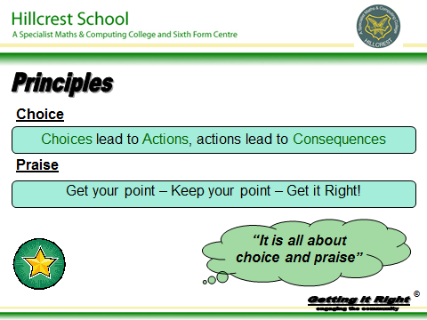



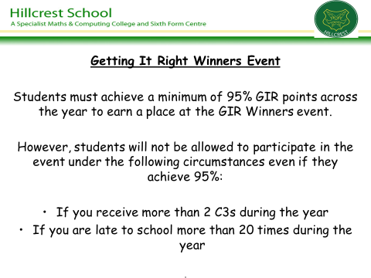

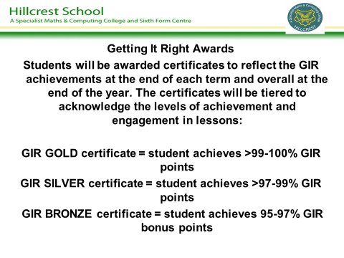

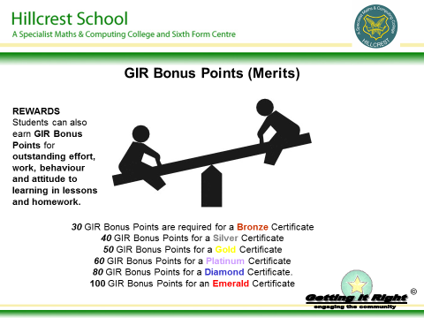


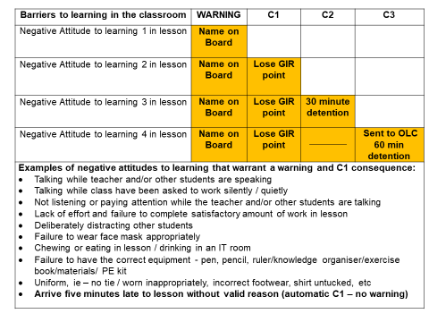

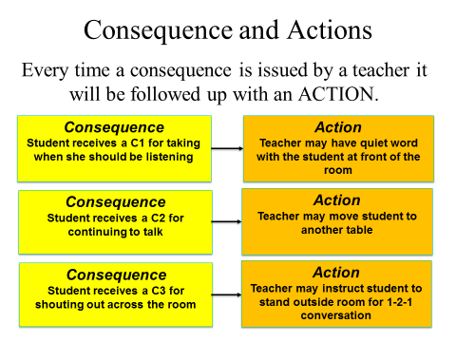

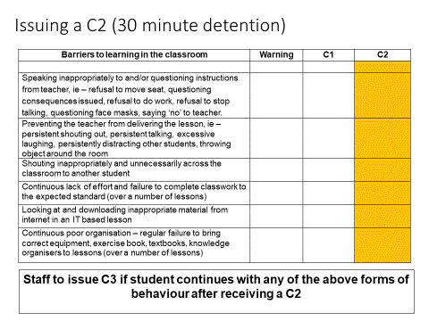
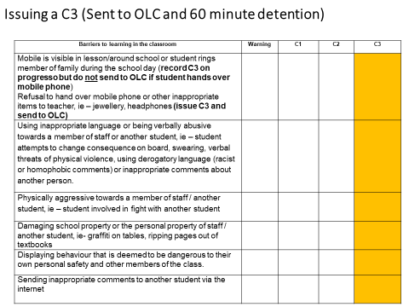

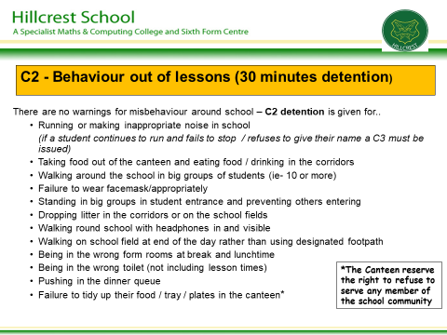

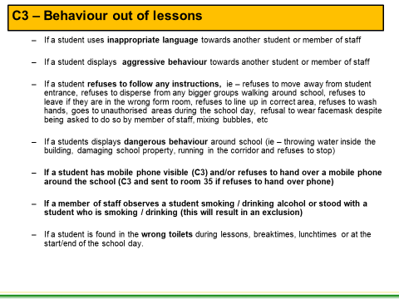

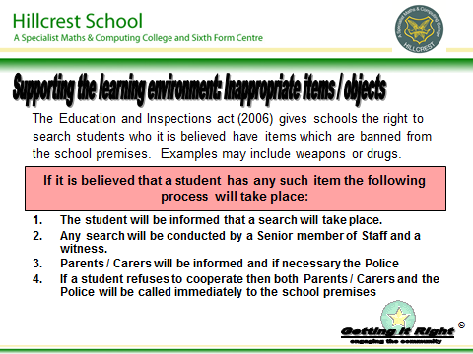

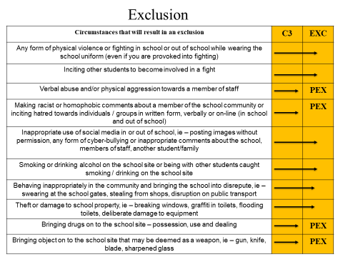

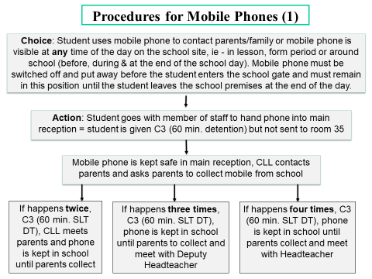
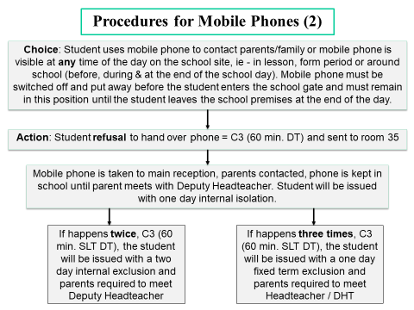

Appendix 2 - Getting It Right Overview 2020-21

Cumulative Consequences C1- C3

Barriers to learning in the classroom | WARNING | C1 | C2 | C3
Negative Attitude to learning 1 in lesson | Name on Board
Negative Attitude to learning 2 in lesson | Name on Board | Lose GIR point
Negative Attitude to learning 3 in lesson | Name on Board | Lose GIR point | 30 minute detention
Negative Attitude to learning 4 in lesson | Name on Board | Lose GIR point |  | Sent to OLC /  60 min detention
Examples of negative attitude to learning that warrants a warning and consequence:
- Talking while teacher and/or other students are speaking
- Talking while class have been asked to work silently / quietly
- Not listening or paying attention while the teacher and/or other students are talking
- Lack of effort and failure to complete satisfactory amount of work in lesson
- Deliberately distracting other students
- Failure to wear facemask / appropriately
- Chewing or eating in lesson / drinking in an IT room
- Failure to have the correct equipment - pen, pencil, ruler/knowledge organiser/exercise book/materials/ PE kit
- Uniform, ie – no tie / worn inappropriately, incorrect footwear, shirt untucked, wearing outdoor coat.
- Five minutes late to lesson without valid reason (no warning – automatic C1)

Issuing a direct C2 consequence (30-minute detention)

Barriers to learning in the classroom | Warning | C1 | C2
Speaking inappropriately to and/or questioning instructions from teacher, ie – refusal to move seat, questioning consequences issued, refusal to do work, refusal to stop talking, refusal to wear facemask/appropriately, saying ‘no’ to teacher.
Preventing the teacher from delivering the lesson, ie – persistent shouting out, persistent talking, excessive laughing, persistently distracting other students, throwing object around the room
Shouting inappropriately and unnecessarily across the classroom
Continuous lack of effort and failure to complete classwork to the expected standard (over a number of lessons)
Looking at and downloading inappropriate material from internet
Continuous poor organisation – regular failure to bring correct equipment, exercise book, textbooks, knowledge organisers

Issuing a direct C3 (Sent to OLC and 60-minute detention)

Barriers to learning in the classroom | Warning | C1 | C2 | C3
Mobile is visible in lesson/around school or student rings member of family during the school day (record C3 on progresso but do not send to OLC if student hands over mobile phone)
Refusal to hand over mobile phone or other inappropriate items to teacher, ie – jewellery, headphones (issue C3 and send to OLC)
Using inappropriate language or being verbally abusive towards a member of staff or another student, ie – student attempts to change consequence on board, swearing, verbal threats of physical violence, using derogatory language (racist or homophobic comments) or inappropriate comments about another person.
Physically aggressive towards a member of staff / another student, ie – student involved in fight with another student
Damaging school property or the personal property of staff / another student, ie- graffiti on tables, ripping pages out of textbooks
Displaying behaviour that is deemed to be dangerous to their own personal safety and other members of the class.
Sending inappropriate comments to another student via the internet
Truanting from school, lesson or form period

Appendix 3 – Guidance on C3 arrangements

Students may be sent to the Centre (Room 35) during the day as a result of their behaviour in lessons and around the school site. Students will remain in the centre for a fixed period of time, depending on the nature of the behavioural issue, and attend a detention at break and lunchtime on either that day or the following day. When staff send a student to the Centre they must send information, via email, immediately to the Centre and complete the appropriate referral through Progresso.
Student receives a C3 and is sent to Room 35 during period 1
Student receives a 60 minute SLT detention**
Student remains in Room 35 for period 1, 2, break / form period*

Student receives a C3 and is sent to Room 35 during period 2
Student remains in Room 35 for period 2, break, form period*

Student receives a 60 minute after SLT detention**

Student receives a C3 and is sent to Room 35 during period 3

Student remains in Room 35 for period 3 and lunch*

Student receives a 60 minute SLT detention**

Student receives a C3 and is sent to Room 35 during period 4

Student remains in Room 35 for period 4 and 5*

Student receives a 60 minute SLT detention**
** Member of staff in the Ce

Student receives a C3 and is sent to Room 35 during period 5

Student remains in Room 35 for period 5 only*

Student receives a 60 minute SLT detention**

*The member of staff in the Centre may decide it more appropriate for the student to remain in the Centre longer depending on the seriousness of the reason for the C3 referral (i.e. blatant refusal to follow instructions in lessons or behaviour that has potentially put the student / other students at risk) or their behaviour when in the Centre. College Learning Leaders may also decide it is more appropriate for a student to remain in the Centre longer (i.e. truancy from lessons, bullying of other students, refusal to co-operate with their instructions)

** Failure to attend the SLT detention will result in students receiving a one day internal exclusion.

Appendix 4
C3 ACTION
Student receives a C3 for behaviour in lessons / around the school site, truancy from lessons / form period or having mobile phone visible in school / refusal to hand over mobile phone to member of staff

Whole School Detention System 2020-21
Homework: ACTION
Student fails to complete homework / completes but not to expected standard
C2 Behaviour: ACTION
Student receives a C2 for behaviour in lessons / around school or failure to wear uniform correctly

STAFF ACTION
Staff record C3 on Progresso

STAFF ACTION
Staff record C1 on Progresso
STAFF ACTION
Staff record C2 on Progresso

CONSEQUENCE
Student issued with 60 minute SLT detention on Friday (Canteen)

CONSEQUENCE
Student issued with ‘Homework Support Detention’ or ‘Homework Improvement Detention’ for 30 minutes on TUESDAY or THURSDAY (Canteen).

CONSEQUENCE

Student issued with 30-minute pastoral detention in the canteen on a TUESDAY or THURSDAY (Canteen)

Failure to attend SLT detention = One-day Internal Isolation

Failure to attend 30-minute detention =
Student issued 60 minutes the following week
Failure to attend 30-minute detention = Student issued with 60 minute detention the following week
Failure to attend a 60-minute detention = student issued with 60 minute SLT detention (Friday)

Supervising the ‘Homework Support Club’:
- The Club will be supervised by six members of staff each night. The duty rota will allocate staff from a mixture of subjects, where possible, to ensure that students can access support from teachers from a range of curriculum subjects.
- Staff issuing the C1 must email details about the missed homework and relevant attachments to homework@hillcrest.bham.sch.uk clearly state the student and subject.
- Staff issuing the C1 must ensure that the student has their exercise book, if necessary, to attend the Club. The letter to parents will remind students of this.
- Departments to provide a list of suitable homework activities that could be completed in detention if student is not able to complete the original homework.
- Detention duty staff to open up emails sent to homework@hillcrest.bham.sch.uk and print out the work for the students to complete.
- Students will be allowed to use the computers to help them complete the homework if necessary. They will be expected to work in silence but will be allowed to discuss their homework or ask for support from the members of staff on duty in the Support Club.
- The completed homework should be put in the pigeon hole of the member of staff who issued the original C1.

Appendix 5: Hillcrest School: Behaviour Stages 1-3

Stage 1 – Form Tutor Report (2 weeks)
Why might a student be placed on this report?
- Receiving 3 consequences in a week
- Late to school two times per week
Student receives 2 or more consequences on Stage 1 report = move to stage 2 CLL report for 2 weeks
Stage 2 – College Leader Report (2 weeks)
Why might a student be placed on this report?
- Receiving 2 or more consequences in a week while on a stage 1 form tutor report
- Receiving 4 consequences in a week
- Late to school three times in a week
- Receiving a C3 consequence in lessons
- C2-C3 for behaviour out of lessons
- Receiving a second cumulative C3 consequence during the year
Student receives 0 consequences = no longer on report, earns 2 bonus points and praise postcard issued
Student receives 1 consequence = no longer on report, earns 1 bonus point and praise postcard issued
Student receives 2 or more consequences on Stage 2 report = move to stage 3 SLT report for 3 weeks
Stage 3 – Senior Leadership Report (3 weeks)
Why might a student be placed on this report?
- Receiving 2 or more consequences in a week while on a stage 2 CLL report
- Receiving a C3 while on stage 2 report
- Receiving 5 consequences in a week
- Late to school four times in a week
- Receiving 2 x C3 consequence in a week for behaviour in/out of lessons
- Receiving a third (or above) cumulative C3 consequence during the year
- Receiving an internal or external exclusion
- Failing to attend 2 SLT detentions
Student receives 0 consequences = no longer on report, earns 3 bonus points and praise postcard issued
Student receives 1-2 consequences = revert to Stage 2 report for one week and praise postcard issued
NB: Student will return to Stage 3 report for 3 weeks if they receive 2 or more consequences in a week after going back on stage 2 report
C3 consequences:
2 x C3 = 1-day internal isolation
3 x C3 = 2-day internal isolation
4 x C3 = 1-day internal exclusion
5 x C3 = 2-day internal exclusion, Behaviour Support Plan and Passport placement
6 x C3 = 1-day external exclusion and meeting with Headteacher
7 x C3 = 2-day external exclusion, meeting with Governors and managed move placement agreed at sharing panel
If behaviour fails to improve on Stage 3 report
If a student on stage 3 report receives three consequences in a week, they will be internally isolated for half a day.
If a student receives a C3 or four consequences in a week, they will be internally isolated for a full day and parents will be invited into school to meet with the DHT. The student will remain on stage 3 report for a further two weeks monitoring.

If there is no improvement in behaviour (ie – C3 or three consequences in the additional monitoring weeks), the student will receive a one-day internal exclusion and parents will be invited back into school to meet the DHT to agree a ‘Behaviour Support Plan’. Targets will be set for further four week monitoring period. If the type of behaviour outlined above continues, the student will receive a two-day internal exclusion and new targets will be set on the Support Plan for a further three week monitoring period.

If there is no improvement in behaviour, despite the actions and interventions outlined above, the student will receive a one-day external exclusion and parents will be invited to attend a meeting with the Headteacher and DHT.

If there is no improvement in behaviour, despite the actions and interventions outlined above, the student will receive another external exclusion (length determined by the nature and frequency of the behaviour issues) and will be placed at sharing panel for either a passport or managed move placement (nature of placement will be decided by Headteacher)

